**DAILY ONLINE ACTIVITIES SUMMARY**

|  |  |  |  |  |  |  |  |  |
| --- | --- | --- | --- | --- | --- | --- | --- | --- |
| **Date:** | **27/06/2020** | | | | | **Name:** | **ASHISH GRACION MENEZES** | |
| **Sem & Sec** | **4&A** | | | | | **USN:** | **4AL18CS012** | |
| **Online Test Summary** | | | | | | | | |
| **Subject** | | **DATA COMMUNICATION** | | | | | | |
| **Max. Marks** | | **30** | | **Score** | | | **26** | |
| **Certification Course Summary** | | | | | | | | |
| **Course** | **STATISTICAL METHODS FOR DECISION MAKING** | | | | | | | |
| **Certificate Provider** | | | **Great Learning** | | **Duration** | | | **7.5 hours** |
| **Coding Challenges** | | | | | | | | |
| **Problem Statement1: Write a C program to print kth digit** | | | | | | | | |
| **Status:Executed** | | | | | | | | |
| **Uploaded the report in Github** | | | | | **YES** | | | |
| **If yes Repository name** | | | | | **https://github.com/ash7745/lockdown-coding** | | | |
| **Uploaded the report in slack** | | | | | **YES** | | | |

Online Test Details1: 18CS46 (D.C) test was conducted on 27/06/2020.The test consisted of 30 questions (MCQ) with each question carrying 1 marks

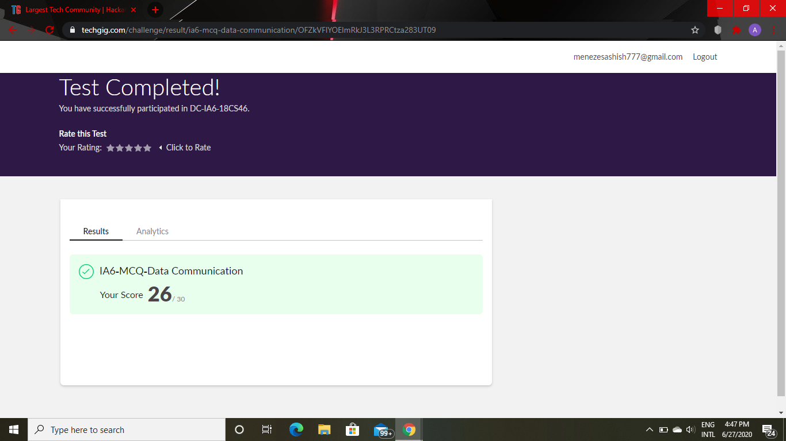

Certification Course Details: STASTICAL METHODS FOR DECISION MAKING

Today I have completed 5 modules

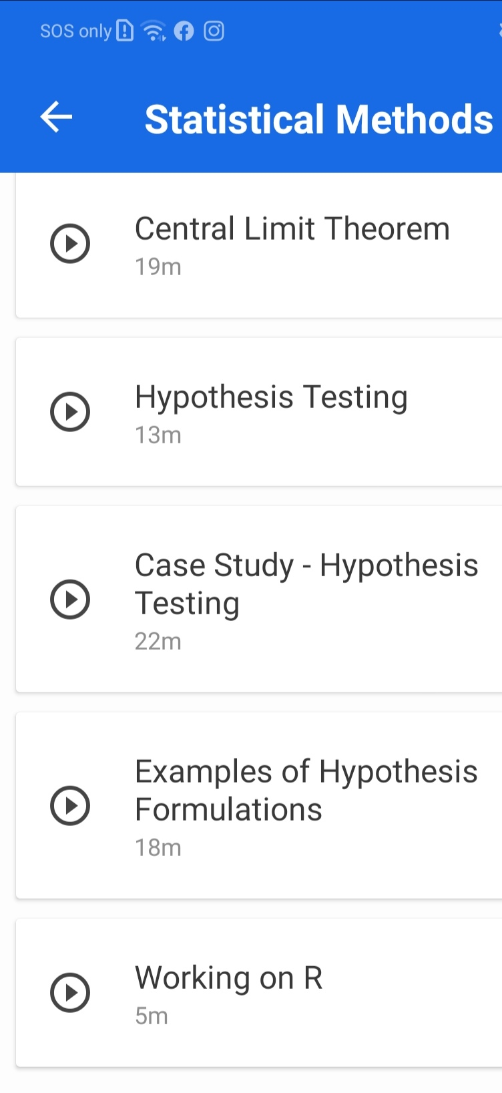

CODING DETAILS: Write a C program to print kth digit

